#UHD Learn Learning Management System

By: Andrew Truong, Daniel Fabela, Hung Ly, Eduardo Rojas, Sumanth Pasipati

1. There are 5 members in our team: Andrew Truong, Daniel Fabela, Hung Ly, Eduardo Rojas, and Sumanth Pasipati
2. Our team used the Waterfall Life Cycle Model and the team model we used is an adjusted chief programmer team model with a team leader (Andrew Truong) and programmers with specific roles.
3. UML Diagrams and artifacts:

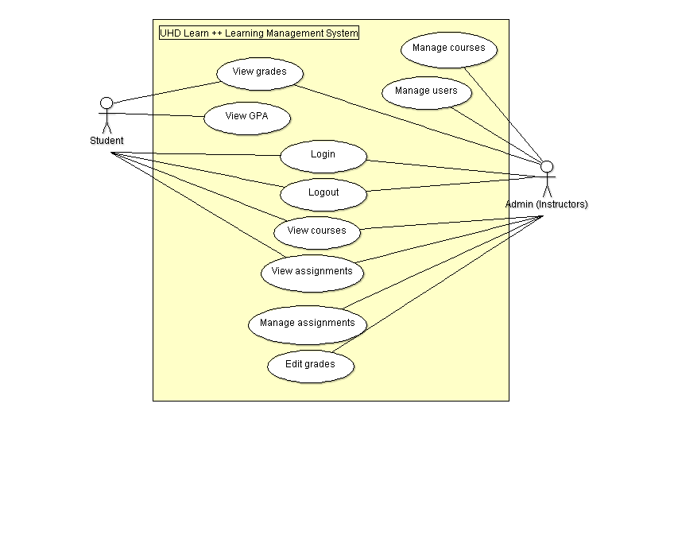

**Figure 1: Use case Diagram**

The use cases of the actors, student and Admin.

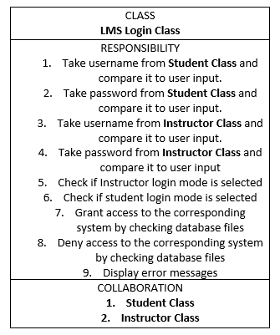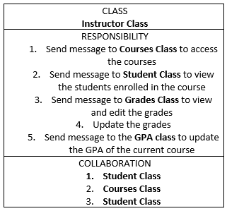

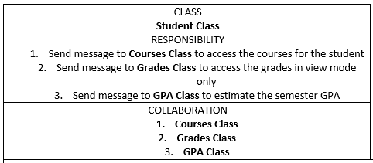

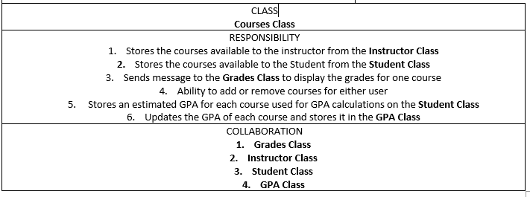

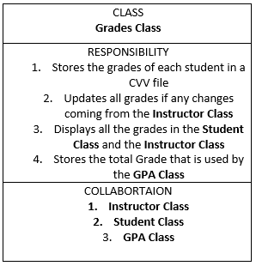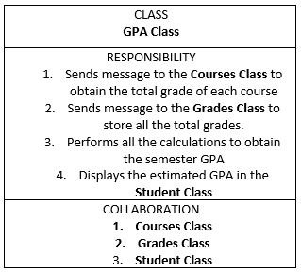

**Figure 2: CRC cards for the different classes**

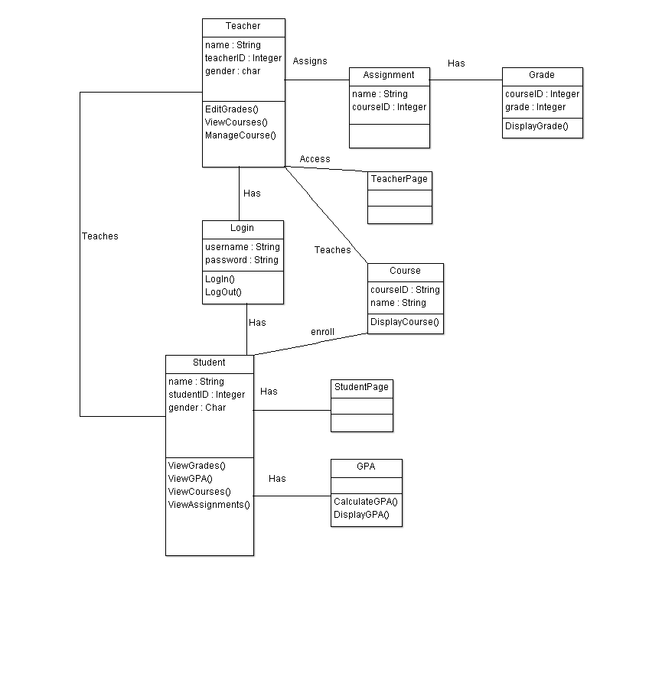

**Figure 3: Class diagram for the different classes and their relations with other classes**

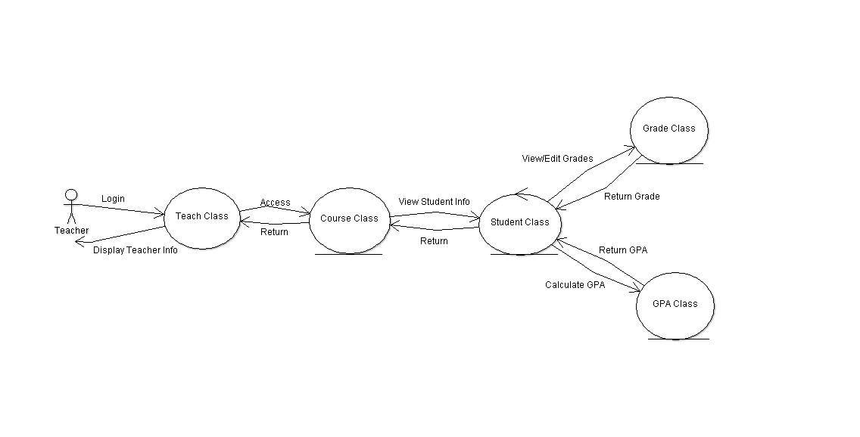

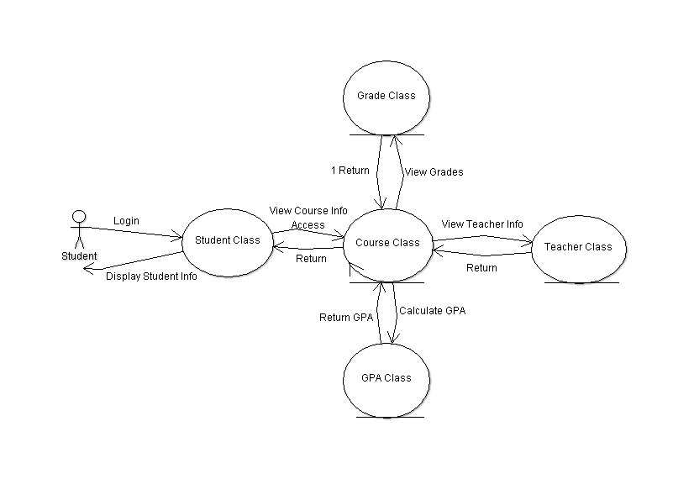

**Figure 4: Collaboration diagram showcasing a use case of the student and teacher**

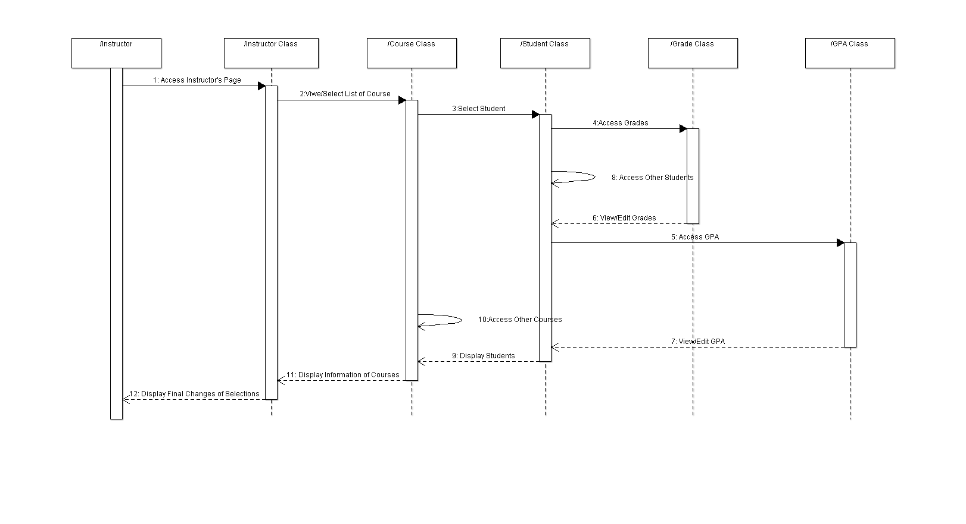

**Figure 5: Sequence Diagram showcasing use cases of the classes**